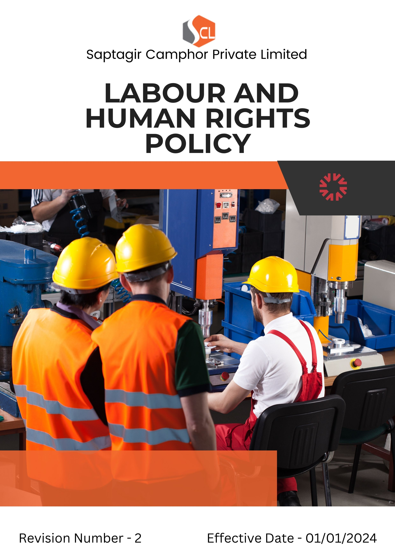
Index

❖ Introduction 3
❖ Scope 3
❖ Labour and Human rights Commitments 4
❖ Quantitative Targets 5
❖ Action Framework 7
❖ Governance & Responsibility 7
❖ Monitoring and Reporting 8
❖ Communication and Transparency 8
❖ Continuous Improvement 8
❖ SDGs (Sustainable Development Goals) Covered in the Labour and Human rights Policy 9
❖ Review 10
❖ Employee Acknowledgment: Labour and Human Rights Policy 11

Introduction
Saptagir Camphor Private Limited (SCPL) is deeply committed to upholding the highest standards of labour and human rights in all aspects of its operations. We recognize that the well-being, health, and safety of our employees and stakeholders are essential to the sustainability of our business. This Labour & Human Rights Policy outlines our initiatives and commitments to ensure that every individual associated with SCPL is treated with dignity, fairness, and respect. Our goal is to foster a supportive, safe, and inclusive work environment that promotes human rights, equity, and continuous career development.

Scope
This policy is applicable across all Saptagir Camphor Private Limited facilities, employees, Workers, contractors, Sub-Contractors, suppliers, and other stakeholders globally, including the communities in which SCPL operates. SCPL ensures that labour and human rights standards are consistently maintained throughout all its sites, operations, and business relationships.

Sr. No. | Address
1. | Vaishnavi's Cynosure, 5th Floor, Telecom Nagar, Gachibowli, Hyderabad – 500032
2 | 13.5 Kms, Gooty Road, B. Kothapalli - 515731, Anantapur (Dist) A.P. INDIA
3 | 3C/2, Mariamma Street, Near Teppakulam, New Ramnad Road, Madurai - 625009, Tamil Nadu, India
4 | No. 106/43B, Jeeva Nagar, (Velan Nagar 1st Street) E.N. Road, Korukkupet, Chennai - 600021, Tamil Nadu, India
5 | No. 51, 5th Cross, 2nd Main Road, Chamarajpet, Bangalore - 560018
6 | 54-3/1-5A, 9th Block, Plot No.44, 2nd Cross Rd, J. Auto Nagar, Auto Nagar, Vijayawada, Andhra Pradesh - 520007

Labour and Human rights Commitments
Saptagir Camphor Private Limited is proud to uphold and promote labour and human rights through its practices and policies:
- Employees Health and Safety: Comprehensive health and safety management systems include regular risk assessments, training programs, provision of appropriate personal protective equipment (PPE), and annual health check-ups for all employees. All facilities comply with local and international health and safety regulations, and potential hazards are proactively monitored and mitigated.
- Working Hours and Overtime Policy: SCPL ensures fair wages, comprehensive benefits, and reasonable working hours aligned with local laws and global best practices. We maintain open communication channels that empower employees to voice their concerns and uphold transparency around employment terms. Employee’s annual Health-Checkup is part of this policy to ensure good healthcare.
- Labour Relations: SCPL supports the rights of employees to freely associate and participate in collective bargaining. We actively maintain structured engagement with trade unions and representatives to ensure a platform for dialogue and collaboration.
- Career Management: SCPL invests in continuous career development through equal opportunities for recruitment, training, and leadership development. Our structured programs aim to provide employees with clear advancement pathways and personal growth.
- Child Labour, Forced Labour and Human Trafficking: SCPL enforces a zero-tolerance policy towards child labour, forced labour, and human trafficking. We take proactive steps to audit suppliers and partners to ensure our standards are upheld throughout the supply chain. We are committed to identifying, preventing, and addressing any risks of human trafficking within our operations and extended supply chain, and we expect the same commitment from all our stakeholders.
- Equal Opportunity and Non-Discrimination: SCPL is committed to fostering a workplace free of discrimination based on gender, race, religion, age, sexual orientation, or disability. We celebrate diversity and create an inclusive environment that empowers individuals to thrive.
- External Stakeholder Human Rights: SCPL respects the human rights of local communities, customers, and partners. We engage proactively with external stakeholders to ensure our operations support and do not infringe upon their rights.

Quantitative Targets
Baseline Year: FY 2022-23 is set as the baseline year for tracking SCPL's labour and human rights compliance and performance.

- Employee Health and Safety
- Maintain 0% workplace incidents by FY 2027-28 through enhanced safety training, random safety audits, and continuous risk assessments.
- Maintain 100% compliance by FY 2027-28 with all local and international health and safety regulations across all facilities.
- Conduct annual health check-ups for 100% of employees.
- Provide PPE and conduct regular fire safety and EHS compliance training for all relevant personnel.

- Working Conditions
- Maintain 100% of employees have access to clear, two-way communication channels (e.g., suggestion boxes, digital platforms) by FY 2027-28.
- Maintain working hours at 8 hours/day and 48 hours/week with 1 day off per week and voluntary overtime not exceeding 4 hours/week.
- Provide overtime pay at 2x basic wage, with annual wage and benefits reviews to ensure fair and competitive compensation packages.

- Labour Relations
- Increase employee participation in collective bargaining activities by 15% by FY 2027-28.
- Hold quarterly meetings with employee representatives to address workplace concerns and improve conditions.
- Ensure all employees are free to associate and bargain collectively, with open engagement channels between management and unions or representatives.
- Career Management and Development
- Offer training and development opportunities to 100% of employees by FY 2027-28.
- Conduct a minimum of one upskilling workshop per quarter for corporate staff.
- Provide an average of 10 hours of human rights training annually per employee by FY 2027-28.
- Achieve 90% employee satisfaction by FY 2027-28 with career development opportunities.
- Child Labour, Forced Labour & Human Trafficking
- Maintain 100% compliance by FY 2027-28 with all local and international Child Labour, Forced Labour & Human Trafficking regulations across all facilities.
- Offer Child Labour, Forced Labour & Human Trafficking training to 100% of employees by FY 2027-28.
- Maintain zero incident of child labour, forced labour, and human trafficking.
- Ensure no employment of individuals under the age of 18, with all supply chain partners fully compliant with SCPL’s labour standards.
- Diversity, Equity & Inclusion (DEI)
- Achieve 15% women in the factory workforce by FY 2027-28.
- Maintain 25% women representation on the board by FY 2027-28.
- Reach gender parity in leadership positions.
- Increase workforce representation from underrepresented groups by 10%.
- Conduct periodic DEI workshops, and track progress through the DEI Committee.
- Harassment and Discrimination
- Maintain zero tolerance and zero incident of workplace harassment and discrimination by FY 2027-28.
- Provide annual harassment and anti-discrimination training to 100o/o of employees by FY 2027-28.
- Conduct risk assessments for discrimination and harassment, covering 1000/" of our locations by FY 2027-28.
- Conduct anonymous workplace culture surveys annually to monitor inclusivity and respect in the work environment.
- Grievance Redressal and Social Protection
- Maintain a 24x7 anonymous grievance reporting platform, with structured escalation through HR and grievance cells.
- External Stakeholder Human Rights & Supply Chain
- Conduct human rights impact assessments covering 100% of Tier 1 suppliers and at least 75% of Tier 2 suppliers annually.
- Participate in a minimum of 1 multi-stakeholder or industry-led human rights initiatives per year.

Action Framework
- Health and Safety Audits: SCPL conducts regular health and safety audits at all facilities to identify risks and take corrective actions promptly.
- Employee Communication Platforms: Two-way communication platforms (such as suggestion boxes and digital feedback systems) are implemented to address concerns regarding working conditions.
- Training Programs: SCPL offers continuous training on safety, leadership, and professional skills development to empower employees and promote career growth.
- Inclusion Initiatives: We organize workshops and diversity training to promote an inclusive workplace culture.
- Risk Assessment: Comprehensive risk assessments are carried out periodically to proactively identify potential hazards in the workplace, evaluate their impact, and implement appropriate mitigation strategies.

Governance & Responsibility
- Human Resources Director: Oversees the implementation of the Labour & Human Rights Policy, ensures compliance, and addresses concerns related to employee relations and workplace conditions.
- Health and Safety Officer: Monitors health and safety standards across all facilities, ensuring the safety and well-being of employees.
- Diversity & Inclusion Committee: Ensures the company is meeting its diversity, equity, and inclusion goals, while fostering an inclusive workplace culture.
- Management and Employees: All levels of management and employees are responsible for adhering to labour and human rights standards and promoting safe, ethical working conditions.

Monitoring and Reporting
- Employee Feedback Surveys: Regular surveys are conducted to assess employee satisfaction with working conditions, safety, and career development.

Communication and Transparency
- SCPL’s Labour & Human Rights Policy is publicly accessible and communicated internally to ensure all employees and stakeholders are informed.
- Employees and external stakeholders are encouraged to report any violations or concerns through confidential reporting channels without fear of retaliation.

Continuous Improvement
SCPL is committed to ensuring the continued accuracy, relevance, and transparency of its Labour & Human Rights Policy and reporting practices. To achieve this:
- Annual Review Protocol: The policy and associated reports will be reviewed annually by a cross-functional team, with inputs from employees, partners, and external stakeholders.
- Benchmarking: SCPL will continuously reassess its practices against evolving global labour and human rights standards (e.g., UN SDGs, ILO conventions, SASB guidelines).
- Audit Integration: All practices and KPIs are reviewed through internal assessments and third-party evaluations such as Together for Sustainability (TFS) audits.
- Feedback Loops: Employee and stakeholder feedback will be used to identify new opportunities for improvement.
- Stakeholder Dialogue: SCPL will actively engage in dialogue with communities, clients, and other key stakeholders to ensure shared responsibility in upholding labour and human rights.
- Commitment to Zero Incidents: SCPL aims to maintain zero incidents related to workplace discrimination, harassment, and safety failures.

SDGs (Sustainable Development Goals) Covered in the Labour and Human rights Policy





Review
The Labour & Human Rights Policy will be reviewed annually by the Human Resources Director for its effectiveness, and relevance. This review will ensure that the policy adapts to changing regulations, stakeholder feedback, and evolving company goals. Updates and changes will be communicated to all employees and stakeholders as necessary.

Approved By:

Designation:

Last Review Date: 01/04/2026
Next Review Date: 01/04/2027

Employee Acknowledgment: Labour and Human Rights Policy
I acknowledge that I have received, read, and understood the Labour & Human Rights Policy of Saptagir Camphor Private Limited. I am aware of the company’s commitment to upholding labour and human rights, ensuring a safe and inclusive work environment, and promoting the health and well-being of all employees.

I understand my responsibilities in supporting this policy, including complying with all applicable labour laws, engaging in open communication regarding working conditions, and participating in initiatives that promote diversity, equity, and inclusion. I agree to adhere to fair labour practices in my daily work, report any violations or concerns, and contribute ideas for continuous improvement.

By signing below, I confirm my commitment to upholding the Labour & Human Rights Policy and supporting SCPL’s efforts toward creating a positive and equitable workplace for all.

Employee Name:

Employee Signature:

Date:

